Data: Raw, unprocessed facts/values; Not carry meaning on their own; Numbers, text, images / symbols; Information: Processed, organized & structured data; Meaningful, useful; Database: Collection of related data; Database Management System: General-purpose software system → defining, constructing, manipulating & sharing databases among users; Database System Environment: HSD-PP; Features: Self describing nature; Enables insulation between programs & data, & data abstraction; Support of multiple views of data; Sharing of data & multiuser transaction processing; Security & access levels; Advantages: Data independence (application/program does not need to know exactly how the data is stored/organized inside the database); Efficient data access (to find & retrieve data quickly, even when the database contains a huge amount of data); Enforcing integrity (provide capabilities to define & enforce constraints; data types); Restricting unauthorized access; Providing backup & recovery; Concurrent access (simultaneous access of data by different users); W/o database designing: Unnecessary data which occupies storage space; Omits data; Takes time; Incorrect, inconsistent data; Unable to accommodate changes in the user's requirements; Database Design Process: ¹Requirement collection & analysis: Concisely written set of users’ requirements; Goals: Determine data requirements of the database in terms of objects; Identify & describe information about these objects; “” the relationships among these objects; “” different transactions that will be performed on the database; “” performance, integrity, security / administrative constraints to be imposed on the database; “” design & implementation constraints if any (specific technologies, hardware & software, programming languages, policies, standards); Gathering: Review of existing documents; Interviews w. end users; Review of existing automated systems; ²Conceptual database design: High-level description of data → Conceptual data model/semantic data model (way of designing a database that focuses on the meaning & relationships of the data, rather than just how data is physically stored); ER/EER Model; ³Logical database design: Determine DBMS to implement database & data model; We utilize the conceptual schema created in previous step & convert it into a schema of a particular data model (Relational Data Model); ⁴Schema refinement: Schema created by the logical database design phase is further refined for potential problems such as redundancies; ⁵Physical database design: Performance criteria are taken into consideration & further enhancements to the schema & creation of indexes are considered; ⁶Security design: Different user groups & their roles are identified; Appropriate levels of access are provided to data ensuring that users have access to only the necessary data; Database Hosting: Defines where & how a database is deployed, stored & accessed; Selecting appropriate hosting type depends on: Scalability; Cost; Security; Performance; Types: On-Premise Hosting; Cloud Hosting; Cloud Database: DBaaS; Self-managed; Relational Cloud Databases (AWS RDS, Azure SQL Database, Google Cloud SQL); NoSQL Cloud Databases (MongoDB Atlas, AWS DynamoDB, Google Firestore, Azure Cosmos DB); Data-intensive applications: Focus on handling large volumes of data rather than performing complex computations; Involve extensive data storage, retrieval & processing; Require fast & consistent access to data; Must be scalable to handle growing data & user loads; Common in systems w. real-time access & multiple concurrent users; Depend heavily on reliable databases & DBMSs for performance & stability; E.g. Facebook, Instagram (Posts, images, comments, likes, user profiles); Amazon, eBay (Product listings, transactions, user carts, reviews); Online banking apps (Customer info, transactions, loan history, statements); Learning Management Systems (LMS), like Moodle (Grades, courses, materials, attendance); Google, Bing (Crawled pages, user queries, ranking metadata); Why DBMS critical for data-intensive applications? Data Storage & Retrieval (Efficient storage of huge volumes of structured data); Indexing (Fast lookups & search operations); Transactions & Concurrency (Handles simultaneous users & operations safely); Security & Access Control (Ensures authorized access to sensitive data); Backup & Recovery (Prevents data loss in case of failure); Query Optimization (Speeds up processing of complex queries); Scalability (Supports growth in data, users & workloads dynamically);
SEQUEL (Structured English QUEry Language): Developed for an experimental relational database system – R; ANSI (American National Standard Institute) + ISO (International Standards Organization) = Standard version SQL in 1986 (SQL I, SQL-86, etc.); SQL2 (SQL-92) is currently in use; It is a comprehensive language; Features: Data Definition Language (DDL); Data Manipulation Language (DML); Facilities for security & authorization; Facilities for transaction processing; Facilities for embedding SQL in general purpose languages (Embedded SQL); Data Definition Language (DDL) – Columns: Supports creation, deletion & modifications for tables & views; Datatypes: INT: Storing whole #s; CHAR(): Fixed length text; Stores exactly $n$ characters; E.g.: NIC, ID; VARCHAR(): Variable-length text up to $n$ characters; Suitable for names, addresses; FLOAT; DATETIME: Stores data & time values (‘2025-07-08 14:00:00); REAL: Stores decimal numbers (floating point); MONEY: Stores currency values w. decimal precision;
Constraint | Purpose
Not Null | Ensures that column doesn’t have null values
Unique | Ensures that column doesn’t have duplicate values
Primary Key | Defines a primary key
Foreign Key | Defines a foreign key
Default | Defines default value for a column (when no values are given
Check | Validates data in a column
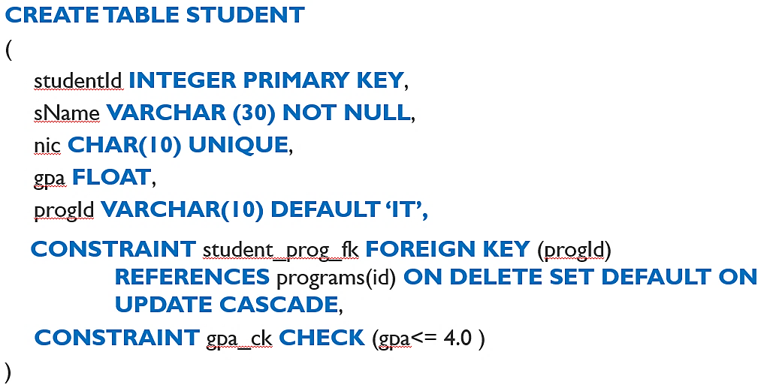
Foreign key: Tail of arrow
Primary key: Head of arrow
When creating tables, those that don’t have foreign keys must be created 1st because tables w. foreign keys depend on the referenced tables; Creating tables in wrong order will result in errors due to missing referenced tables; ADD CONSTRAINT chk_doctor_nic CHECK (doctor_nic LIKE '[0-9][0-9][0-9][09][0-9][0-9][0-9][0-9][0-9][Vv]'): NIC must be exactly 9 digits followed by letter ‘V’;
DDL | SQL Command | What it does?
ALTER | ALTER TABLE student ADD age INT | Adds new column to table
ALTER | ALTER TABLE student  ADD CONSTRAINT chk_age CHECK (age > 18) | Adds new constraint to column
ALTER | ALTER TABLE student DROP COLUMN age | Removes column from table
DROP | DROP TABLE Employee | Deletes table
DROP | DROP CONSTRAINT constraint_name | Deletes constraint
Constraints in SQL
Constraint | Syntax | Definition
Primary Key Constraint | PRIMARY KEY (column_name) | Uniquely identifies  each record in a  table; Values must be  unique & not null; Each table can have  only one primary key;
Primary Key Constraint | CONSTRAINT <constraint_name>  PRIMARY KEY (column_name)
Foreign Key Constraint | FOREIGN KEY (referencing_column)  REFERENCES <referenced_table>  (referenced_column) | Used to link two  tables together; Foreign key in one table refers to the primary in another; Enforces referential integrity;
Foreign Key Constraint | CONSTRAINT <constraint_name>  FOREIGN KEY (referencing_column)  REFERENCES <referenced_table>  (referenced_column)
Check Constraint | CHECK (condition) | Limits the values that can be entered in a column based on a condition
Check Constraint | CONSTRAINT <constraint_name>  CHECK (condition)
Data Manipulation Language (DML) – Rows: Allows to write statements to insert, delete, modify & display;
DML | SQL Command | What it does?
INSERT | INSERT INTO table VALUES (v1, v2, v3) | Inserts a row
INSERT | INSERT INTO table(field1, field2, field3)  VALUES (v1, v2, v3) | Inserts a row
SELECT | SELECT studentId FROM student  WHERE gpa > 3.0 | Retrieves information
UPDATE | UPDATE student  SET gpa=2.8 WHERE studentId=1001 | Update a row
DELETE | DELETE student WHERE studentId=1000 | Deletes a row
Clauses & Operations used w. SELECT
Clauses | SQL Command | What it does?
[NOT] LIKE | SELECT name FROM student  WHERE name LIKE ‘A%’ | %: Any sequence of characters  _: Any single character
IS [NOT] NULL | SELECT name FROM student  WHERE name IS NULL | Checks whether attribute value is null
DISTINCT | SELECT DISTINCT name  FROM student | Selects distinct value from duplicates
[NOT] BETWEEN | SELECT studentId FROM student  WHERE gpa BETWEEN 3 AND 4 | Checks whether attribute value is within a range
[NOT] IN | SELECT studentId FROM student WHERE gpa IN (1, 2, 3) | Match any value from specified list
[NOT] IN | WHERE gpa = 1 OR gpa = 2 OR gpa = 3 | Match any value from specified list
ORDER BY  (can have aggregate functions) | SELECT name, gpa FROM student  ORDER BY gpa | Orders in ascending (ASC) order based on a given field
ORDER BY  (can have aggregate functions) | SELECT name, gpa FROM student  ORDER BY gpa DESC | “” descending order
Aggregate | SELECT AVG(gpa) AS ‘Average’  FROM student | Summarizes results of rows
GROUP BY | SELECT cid, COUNT(sid) AS count  FROM course GROUP BY cid | Groups data & produces single summary row for each group
HAVING | SELECT cid, COUNT(sid)  FROM course GROUP BY cid HAVING COUNT(sid) > 2 | Apply conditions on groupings (allows us to filter groups based on aggregate function results); Must be after GROUP BY
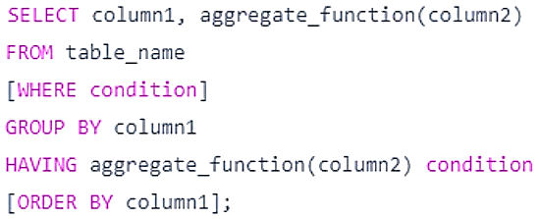
‘%a’: Names contain the letter ‘a’ anywhere; ORDER BY age, salary DESC: Orders ascending by age, descending by salary; SELECT COUNT(eid) AS emp_id: Stores total count of employees inside emp_id variable; SELECT COUNT(eid) AS ‘Employee ID’: But this displays total count of employees as ‘Employee ID’; Aggregate Function: Performs calculation on a set of values & returns a single summarized result; Essential for creating reports, summaries & analytics; These ignore NULL values during computation; SUM(): Total sum of numeric column; COUNT(): # of rows that matches a specific criterion; AVG(): Average value of numeric column; MIN(): Smallest value of selected column; MAX(): Largest “”; ROUND(): Round up to a specific decimal place; FIRST(): 1st value in a column LAST(): Last “”; GROUP BY: Arrange identical values into groups (when used w. aggregate functions); If particular column has same value in multiple rows, it’ll collect those rows into single group, allowing us to perform calculations on each group; When grouping: ¹Each item in the SELECT list must be single valued per group; ²SELECT clause may only contain Columns names, aggregate function, constants, expression involving combinations of the above; ³All column names in SELECT list must appear in the GROUP BY clause unless the name is used only in the aggregate function; Joins (inner & outer); Nested query (IN: Value matches one of the values; SOME; ANY: Comparison must be true for at least 1 value in the list; ALL: Comparison must be true for every value in the list), [NOT] EXISTS; GROUP BY – HAVING clauses; AND, OR: Combine multiple conditions; Operators: =, >, <, >=, <=, <> (not equal, some version have !=); Table Joining: Rows are combined based on related columns (usually a foreign key referencing a primary key); SELECT <column_name(s)> FROM table1 <alias for table1> WHERE condition; Alias: Provides a temporary name for a table/column; Only exists during execution of the query;
Join | SQL Command |  | What it does?
INNER JOIN | SELECT s.Name, p.OfferBy  FROM student s, program p  WHERE s.pid=p.progId AND offerBy=‘SLIIT’ |  | Combines data
INNER JOIN | SELECT s.Name, p.OfferBy  FROM student s  INNER JOIN program p  ON s.pid=p.progId  WHERE offerBy=‘SLIIT’ |  | Combines data
LEFT OUTER JOIN | SELECT s.Name, p.OfferBy  FROM student s  LEFT OUTER JOIN program p  ON s.pid=p.progId | Returns all rows from left of join w. matching rows on right of join  (Result is null in right side when there is no match)
Conceptual Database Design: High-level conceptual data model → Entity-Relationship (ER) model; Entity: Object in real world w. an independent existence (place, car, house, etc.); Entity set: Collection of similar entities; First letter of each word in the entity name is uppercase; Normally an entity is named using a noun/noun phrase; Attributes: Entity is described using a set of attributes; Domain: Domain of an attribute specifies the set of possible values that the attribute can have; E.g.: age: integer values from 0-120; Composite Attributes: Can be divided into smaller sub parts; E.g.: Name → First name, Middle name; Multi-valued Attributes: Attributes containing multiple values; E.g.: 1 student may have multiple phone no.; Derived Attributes: Age can be derived from date of birth; Denoted by dotted oval circle; Key Attributes: Minimal set of attributes which uniquely identify an entity in the entity list; Primary Key: There can be multiple key attributes called candidate keys in a single entity; A single candidate key is designated as the primary key; Minimal set of attributes that uniquely identify the relation; E.g.: An entity may have eid and nic as the candidate keys, but eid is only chosen as the primary key; Composite Key: A group of attributes make up the key; E.g.: Composite key = (ST_ID + Unit_ID); Super Key: Any other set of attributes that uniquely identify a tuple; E.g.: (SID + Name) is unique, but not the minimal set. This is referred to as Super Key; Relationship: Association among ≥ 2 entities; Relationship Set: Collection of similar relationships; Named using a verb/verb group; Degree: # of participating entities in the relationship; Binary (2 degrees); Ternary (2 degrees); Quaternary (4 degrees); Cardinality ratio: For a binary relationship; Specifies # of relationship instances that an entity can participate in; one-to-one (1:1); one-to-many (1:N); many-to-many (N:M); Descriptive Attributes: Used to record information about the relationship rather than any one of the participating entities; Participation Constraint: Specifies whether the existence of an entity depends on its being related to another entity via the relationship type; Total Participation: Employee must always work for a department; Partial “”: Department may/may not have employees; Weak Entity: Can’t exist on its own; Don’t have any key attributes; Its existence-dependent on another entity (it can’t exist w/o the entity w. which it has a relationship); It inherits the part of primary key from the entity which it’s related; Partial Keys: Attributes in weak entity participating in the key; Owner entity & weak entity participates in an identifying relationship; Cardinality of identifying relationship is either one-to-one or one-to-many from owner entity to weak entity; Weak entity must have total participation in the identifying relationship; EER Model: Enhanced ER model; Extensions: Specialization: Process of defining a set of subclasses of an entity type (employee & permanent employee); Generalization: Process of identifying commonalities between entity types & grouping them as super-classes; ISA Relationships: Sub classes may have their own attributes & relationships; Every entity in subclass is also a type of parent class & have all attributes of parent class; Overlapping Constraint: Determine whether 2 subclasses are allowed to contain same entity; E.g.: Can an employee be a permanent employee & a contract employee? If they’re not overlapping, then it’s disjoint; Covering Constraint: Determine whether entities in subclasses collectively include all entities in super class; E.g.: Does every employee belong to one of its subclasses (permanent employee or contract employee)? Does every person in a university belong to either student subclass/faculty member subclass? If not, then it’s partial; Existence of covering constraint → Total specialization; Absence “” → Partial specialization; Aggregation: Functions as similar to if statements; E.g.: Cricket player play in cricket matches. When he plays a match for his performance he may win awards; Difference between ternary & aggregation: Aggregation contain 2 independent relationships; Ternary contains 1;
Logical Database Design: Conceptual DB design → Database schema in the model of chosen DBMS; Before 1970 most DB systems were based on 2 older data models (Hierarchical & Network Models); Leading DBMS products nowadays are based on relational model which introduced by Codd in 1970; Relational Model: Major advantage → Simplicity in data representation; Relational Database: Collection of relations w. distinct relation names; Main construct representing data in relational model is relation; Relation consists of relational schema & relational instance; Relational schema describes columns for a relation; Schema species the relation’s name, the name of each field & the domain of each field; Instance of a relation is a set of tuples (records), in which each tuple has same # of fields as relation schema; Relation instance can be thought of as a table in which each tuple is a row & all rows have the same # of fields; Mapping ISA Relationships: Multi-relation options: Option 1 & 2; Single-relation options: Option 3 & 4;
 | Option 1 | Option 2 | Option 3 | Option 4
Disjoint (Independent)
Overlapping
Covering (Total)
Partial
Schema Refinement: Systematic process for analyzing a relational schema w. the aim of minimizing redundancies & minimizing insertion, deletion & update anomalies; Process performs a series of tests called normal form tests to check whether the schemas meet certain conditions & those relations that are unsatisfactory are decomposed in to smaller relation; Normalization is based on functional dependencies; Schemas such as Employee(eid, ename, did, dname) lead to several anomalies while inserting, updating & deleting & wasting of space due to redundancies of data; Insertion Anomaly: Inserting new employee to the emp table → Department information is repeated; Inserting department w. no employees → impossible since eid cannot be null; Deletion Anomaly: Deleting last employee from department will lead to loosing information about department; Update Anomaly: Updating department’s location needs to be done for all employees working for that department; To solve this, we should decompose relations to smaller relations → Employee(eid, ename, did), Department(did, dname); Random decompositions may introduce new problems; 2 properties that could be looked up to ensure that the relations resulted from decompositions are good: Loss-less join property: Enables recovery of original relation from a set of smaller relations resulted through decomposition; Dependency preserving property: Enables to enforce any constraint on original relation simply enforcing some constraints on each of smaller relation; Functional Dependency: Relationship that exists when 1 attribute uniquely determine another attribute; E.g.: Suppose we have student(id, name) → Here, id attribute uniquely identifies name attribute of student table because if we know student id, we can tell the student name associated w. it; This is known as functional dependency & can be written as id → name or in words, we can say name is functionally dependent on id; Redundancies in relations are based on functional dependencies; Mathematical Definition of FD: Denoted by $X$ → $Y$, where $X$ & $Y$ are sets of attributes in relation $R$, specifies following constraint: Let $t_{1}\left[X\right]=t_{2}[Y]$ then $t_{1}\left[Y\right]=t_{2}[Y]$, where $t_{i}[X]$ represents the values for $X$ in tuple $t_{i}$; Keys & FDs: Key constraint is a special case of a FD where the attributes in the key play the role of $X$ & the set of all attributes play the role of $Y$; Normalization process analyzes schemas based on keys & on the functional dependencies among their attributes; To start normalization it’s essential to find keys of a given relation; Attribute closure of an attribute set $X$, denoted by $X^{+}$ can be defined as set of all attributes which can be functionally determined from it; If $X^{+}=$ all attributes, then $X$ is a key; Computing Keys using Armstrong Axioms: $X,Y,Z$ are sets of attributes: Reflexivity: If $X⊆Y$, then $Y→X$; $X→X$; Augmentation: If $X→Y$, then $XZ→YZ$ for any $Z$; Transitivity: If $X→Y$ & $Y→Z$, then $X→Z$; Union: If $X→Y$ & $X→Z$, then $X→YZ$; Decomposition: If $X→YZ$, then $X→Y$ & $X→Z$; Super Key: Set of attributes $S$ in relation $R$ such that no 2 distinct tuples $t_{1}$ & $t_{2}$ will have $t_{1}\left[S\right]=t_{2}[S]$; Key: Super key w. additional property that removal of any attributes from key won’t satisfy key condition; Candidate Key: Each key of relation; Primary Key: A candidate key is chosen to be the primary key; Prime Attribute: Attribute which is a member of a candidate key; Nonprime Attribute: Attribute which isn’t prime; Attribute Closure Method; Normal Forms: Refers to a series of test performed on relational schemas to improve their goodness; Test for each normal form is performed in a top-down fashion; Normal form of a relation refers to the highest normal form condition it meets; Need to follow steps in order: 1NF → 2NF → 3NF → BCNF; 1st Normal Form: If domains of all attributes in relation are atomic (simple & indivisible); 1NF is now considered to be part of formal definition of a relation in relational model since it allows only atomic values & disallows multivalued attributes & composite attributes; 2nd Normal Form: If every nonprime attribute $A$ in $R$ is fully dependent on any key of $R$ (if it partially depends → violating 2NF); 2NF is based on the concept of full functional dependency; A functional dependency $X→Y$ is a full functional dependency if removal of any attribute $A$ from $X$ means that dependency doesn’t hold any more; E.g.: In a relation $R(ABCD)$ where $AB→\{ABCD\}$, if $A→C$, $A→C$ is a partial dependency (not fully functional dependent); 3rd Normal Form: If every, $R$ is in 2NF & no nonprime attribute is transitively dependent on any key (if nonprime transitivity depends on any key (both sides are nonprime) → violating 3NF); 3NF is based on the concept of transitive dependency; A functional dependency $X→Y$ in a relational schema $R$ is a transitive dependency if there’s a set of non-prime attributes $Z$ where both $X→Z$ & $Z→Y$ hold; Boyce-Codd Normal Form: If every nontrivial functional dependency $X→A$ hold in $R$, then $X$ is a super key of $R$ (left side is super key); If $A$ is super key of $R$ (right side is super key) → violating BCNF;
View: Virtual table which is derived from other tables (base tables/defining tables); Doesn’t exist in a physical form; Creating view: CREATE VIEW is used to define views; CREATE VIEW <view_name>(parameters) AS SELECT <column_name(s)> FROM <table_name> WHERE <condition>; Dropping view: DROP VIEW <view_name>; Updating view can be ambiguous (views containing aggregate functions aren’t updateable); Views containing a join can be ambiguous; Thus, in many DBMSs, views are updateable only if they are defined on a single base table; Advantages: Security: Each user can be given permission to access the database only through a small set of views that contain the specific data the user is authorized to see, thus restricting the user's access to stored data; Query Simplicity: A view can draw data from several different tables & present it as a single table, turning multi-table queries into single-table queries against the view; Disadvantages: Performance: Views create the appearance of a table, but DBMS must still translate queries against the view into queries against the underlying source tables; If the view is defined by a complex, multi-table query then simple queries on the views may take considerable time; Update restrictions; T-SQL: Transact-SQL; Similar to a programming language; Certain extensions have been made in SQL to program simple server-side logic; Variables: T-SQL local variable is an object that can hold a single data value of a specific type; ¹Used as a counter either to count the number of times a loop is performed / to control how many times the loop needs to perform; ²To hold a data value to be tested by a control-of-flow statement; ³To save a data value to be returned by a stored procedure return code; Initializing variable: DECLARE @<variable name> <data type>; Created variable will be holding a null value; SET: Assigns a value to variable; SET @<variable name>=<value>; WHILE: Sets a condition for the repeated execution of an SQL statement/statement block; Statements are executed repeatedly as long as the specified condition is true; Execution of statements can be controlled from inside the loop w. BREAK & CONTINUE keywords; BREAK: Causes an exit from innermost WHILE loop; Any statements appearing after the END keyword, marking the end of the loop, are executed; CONTINUE: Causes WHILE loop to restart, ignoring any statements after the CONTINUE keyword; Stored Functions/Procedures: Business logic is maintained in database tier for data intensive operations; In SQL Server 2005, Stored Procedure/Functions can be written in T-SQL & any .NET language; Function: CREATE FUNCTION <function name> (@<parameter> <data type>) RETURNS <return type> AS BEGIN <function body> RETURN <@variable> END; Parameter mode of parameters for functions is IN which parameters allow the calling code to pass values into the procedure; Procedure: CREATE PROCEDURE <procedure name> (@<parameter> <data type>) AS BEGIN <procedure body> END; Each parameter to a procedure should’ve a data type & a parameter mode (IN or OUT); IN: This is the default mode; IN parameters allow the calling code to pass values into the procedure; OUT: Allow the procedure to pass values back to the calling code; Dropping procedure: DROP PROCEDURE <procedure_name>; Calling the function: EXEC @variable = <function name> ‘parameter’; Calling the procedure: EXEC <prodecure name> <parameter>; Triggers: Special type of stored procedure that automatically takes effect when data in a specified table is modified; Useful in enforcing business rules & data integrity; More powerful than general constraints; E.g.: Employees salary is always less than his manager’s salary; Trigger is invoked in reponse to a: DDL statement (CREATE, ALTER etc.) or DML statement (INSERT, UPDATE, DELETE); FOR|AFTER: AFTER specifies that the DML trigger is fired only when all operations specified in the triggering SQL statement have executed successfully; AFTER is the default when FOR is the only keyword specified; AFTER triggers cannot be defined on views; INSTEAD OF: Specified that the trigger is executed instead of the triggering SQL statement, thus overriding the actions of the triggering statements; Specifies at most, on INSTEAD OF trigger per INSERT, UPDATE, DELETE statement can be defined on a table/view; [DELETE] [,] [INSERT] [,] [UPDATE]: Keywords that specify which data modification statements, when attempted against this table/view, activate the trigger; At least 1 option must be specified; INSERTED/DELETED Tables: When a trigger is executed SQL server creates 2 virtual tables called INSERTED & DELETED; DELETED table stores copies of affected rows during DELETE & UPDATE statements; INSERTED table stores copies of affected rows during INSERT & UPDATE statements; E.g.: When inserting a record to a table, SQL server creates a virtual table called INSERTED & loads data into the inserted table then executes the trigger statements & writes the related data pages; The format of the inserted & deleted tables in the same as the format of the table on which the trigger is defined; Each column in the inserted & deleted tables maps directly to a column in the base table; Subqueries (Nested Queries): SQL query written inside another SQL query; Inner query produces a result that is used by the outer query; SELECT … FROM … WHERE column operator (SELECT …); Inner query → Result → Outer query uses the result; Subquery returns value/row suitable for a single comparison; Subquery can return multiple values instead of 1 (IN, NOT IN, ANY, ALL);
Formal query languages: Relational Algebra: Set of operations defined in relational model for manipulating relational databases; Used as the basis for implementing & optimizing RDBMS; Concepts of relational algebra are incorporated in SQL for RDBMS; Relational algebra consists of a few operators: These operators can operate on ≥ 1 relations & produce a new relation which can be further manipulated using relational algebra; Unary operators: Operate on a single relation; Project operator: Selects certain columns from the table & discards other columns; Duplicate rows are eliminated; $π_{Name, Salary}(EMP)$ selects only the Name & Salary columns from EMP table & discards other columns; Select operator: Used to select a subset of tuples from a relation that satisfies a selection condition; selection condition = boolean expression w. a set of clauses (AND, OR, NOT) boolean operators; Condition may include =, <, >, ≤, ≥, ≠; $σ_{Dno=5}(EMP)$ selects only the rows which satisfies Dno=5 condition & discards other rows; Rename operator: In general, several relational algebra operators are applied one after another; This could be done by nesting relational operators / it could be applied one operation at a time & creating intermediate relations; For the latter case, a name should be given to the relation resulted by applying the 1st operation before the 2nd operator is applied; $π_{Name,Salary}(σ_{Dno=5}\left(EMP\right))$ could be performed with: $Dep5_emps⟵σ_{Dno=5}(EMP)$ or $ρ_{Dep5_emps}(σ_{Dno=5}\left(EMP\right))$; $RES⟵π_{Name,Salary}(Dep5_emps)$; Where intermediate & result relations are renamed; $Temp⟵σ_{Dno=5}(EMP)$ and $R\left(full_name,sal\right)⟵π_{Name,salary}(Temp)$ can be written together as, $ρ_{R\left(Full_name,sal\right)}(σ_{Dno=5}\left(EMP\right))$; Set operators: Based on set theory; 2 relations R & S are said to be union-compatible if: Degree (columns/attributes) of R & S are equal; If corresponding fields of R & S, taken from left to right have same domains (same data types); 3 operations (union, intersection & set difference) could be performed on 2 union-compatible relations R & S; Union: $R∪S$; Intersection: $R∩S$; Set difference: Includes all tuples in R that is not in S; $R-S=(R∩S')$; Binary operators: Operate on 2 tables; Cartesian product: Cross product; Combines every tuples from one relation w. every tuple from the other relation; $EMP×DEPT$; $\left(a,b\right)×\left(c,d\right)=ac,ad,bc,bd$; Equi Join: Combines related 2 tuples from 2 relations into single tuple; Comparison operator used for joining is ‘$=$’; Results of an equi join would have ≥ 1 pairs of attributes that have identical values in every tuple; $EMP⋈_{Dno=Dnumber}DEPT$; Natural Join: Similar to equi join but removes the 2nd redundant attribute from results of an equi join; Requires that 2 join attributes have same name in both relations; $EMP*DEPT=EMP⋈_{Dno=Dno}DEPT$; Outer Joins: Doesn’t ignores non-matching tuples; Null values aren’t eliminated; Some queries require these tuples; Left Outer Join: Provides all combinations of tuples in R & S that are equal on their join attribute; Also returns tuples in R that have no matching tuples in S; R ⟕_{Dept=DeptName} S; Right Outer Join: Returns tuples in S that have no matching tuples in R; R ⟖_{Dept=DeptName} S; Full Outer Join: Combines the results of left & right outer joins; R ⟗_{Dept=DeptName} S; Aggregate functions: Can summarize data; Used in simple statistical queries that summarize information from tuples in a relation; SUM, AVERAGE, MAXIMUM, MINIMUM, COUNT; $I_{<function list>}(R)$; $I_{COUNT ID,AVERAGE Salary}(EMP)$; Grouping: Grouping tuples in a relation by the value of some of their attributes & then applying aggregate functions independently for each group; $<grouping attribute>I_{<function list>}(EMP)$; $Dno I_{COUNT ID, AVERAGE Salary}(EMP)$ this groups by Dno & gives the counts and average salary of each Dno groups;
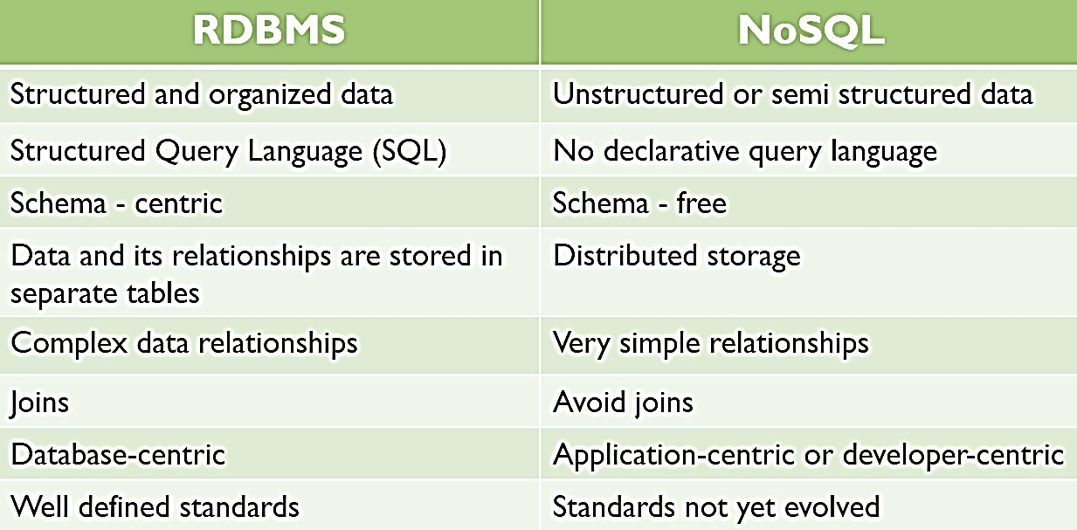
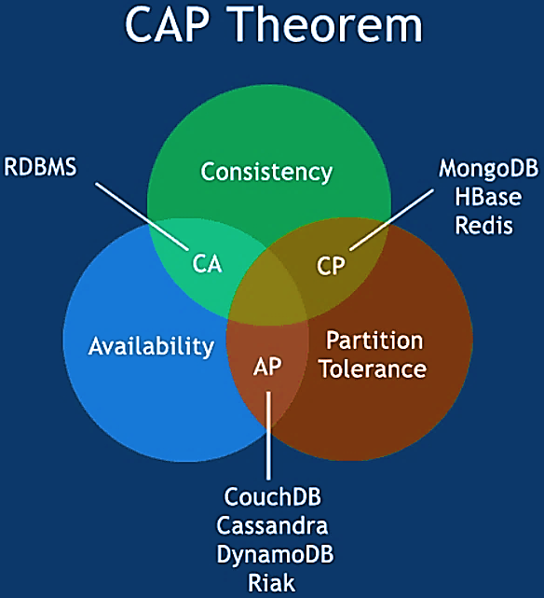
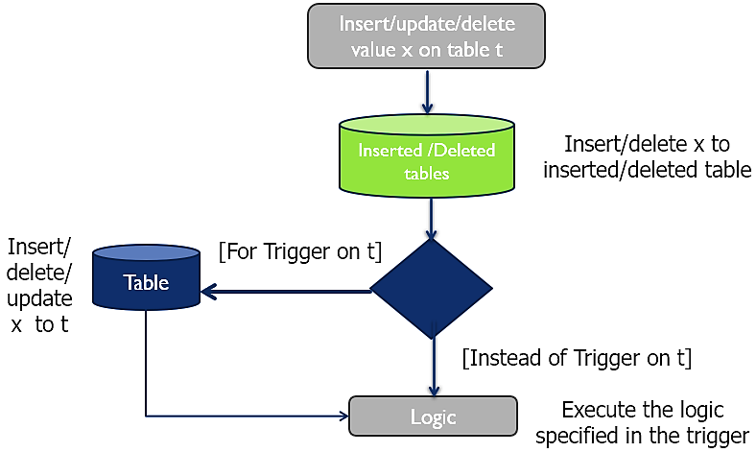
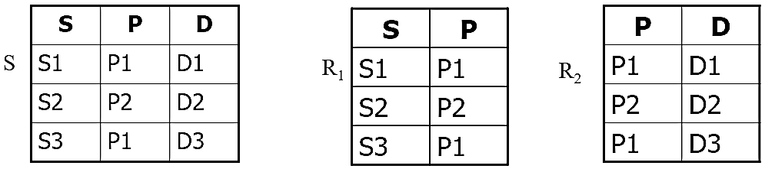
Relational databases: Uses tables, rows & columns; Perfect for structured data; Non-Relational Databases (NoSQL): Modern systems need to handle massive, fast & varied data (Big Data, IoT, social media); High scalability & availability; Flexible schema for unstructured data; Distributed storage across clusters; E.g.: MongoDB, Cassandra, Redis, Neo4j; Traditional RDBMS struggles w.: Large, distributed datasets; Real-time & high-velocity data; Dynamic/unstructured data models; Solution: Web companies (Google, Amazon, Facebook) built internal scalable systems (e.g., BigTable, DynamoDB); NoSQL: Provides horizontal scaling, replication & eventual consistency; First used at an informal meetup in 2009 in San Francisco (presentations from Voldemort, Cassandra, Dynomite, HBase, Hypertable, CouchDB & MongoDB); Not using the relational model (nor SQL language); Designed to run on large clusters (horizontally scalable); No schema – fields can be freely added to any record; Open source; Based on the needs of 21st century web estates; Easy replication support (fault-tolerance, query efficiency); Simple API; Eventually consistent (not ACID); Who uses: Google, Twitter, Facebook, LinkedIn, Adobe; CAP Theorem: Consistency: Data in database remains consistent after execution of an operation; After update operation, all clients see the same data; Availability: System is always on; Partition Tolerance: System continues to function even the communication among servers is unreliable; BASE Concept: Vague term often used as contrast to ACID; Basically Available: System works basically all the time; Partial features can occur, but w/o total system failure; Soft state: System is in flux, non-deterministic state; Changes occur all the time; Eventual consistency: System will be in some consistent state; At some time in future; Types of non-relational databases: Key-value Stores: Simplest NoSQL databases; Every single item in database is stored as an attribute name (or key), together w. its value; E.g.: Riak, Voldemort, Redis, Amazon DynamoDB, Infinispan, Hazelcast, EHCACHE, MapDB, RocksDB, Oracle Berkeley DB 12^{c}, LevelDB, MemCached; Document Databases: Pair each key w. a complex data structure known as document; Documents can contain many different key-value pairs, or key-array pairs, or even nested documents; E.g.: MongoDB, ClusterPoint, CouchDB, MarkLogic, OrientDB, RavenDB, Terrastore, PostgreSQL, MS Azure DocumentDB, Amazon DynamoDB; Graph Stores: Used to store information about networks, such as social connections; E.g.: Neo4J, Hyper, GraphDB, OrientDB, Apache Giraph, Titan, InfiniteGraph; Wide-column Stores: Optimized for queries over large datasets & store columns of data together, instead of rows; E.g.: Cassandra, Hbase, Google BigTable, HyperTable, Accumulo; Reasons to choose NoSQL databases: To improve programmer productivity by using a database that better matches an application’s needs; To improve data access performance via some combination of handling larger data volumes, reducing latency & improving throughput; Choosing NoSQL Databases: Key-value databases are generally useful for storing session information, user profiles, preferences, shopping cart data; Document databases are generally useful for content management systems, blogging platforms, web analytics, real-time analytics, ecommerce-applications; Graph databases are very well suited to problem spaces where we have connected data such as social networks, special data, routing information for goods & money, recommendation engines; Column family databases are generally useful for content management systems, blogging platforms, maintaining counters, expiring usage, heavy write volume; Current trends in NoSQL databases: Multi-Model Databases – support multiple data types (ArangoDB); Serverless Databases – auto-scaling NoSQL in cloud (Firebase, DynamoDB); Integration w. AI & Analytics – real-time data pipelines; Polyglot Persistence – using both SQL & NoSQL in hybrid systems; Increased focus on data governance & consistency; Challenges in non-relational data modelling: Lack of standard query languages; Difficulty enforcing relationships; Eventual consistency complicates real-time data; Migration from relational to NoSQL requires re-designing schema logic; Limited trained expertise & tooling compared to RDBMS;
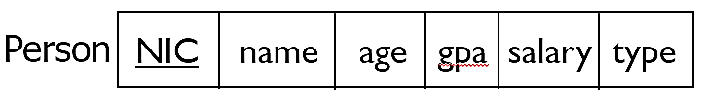
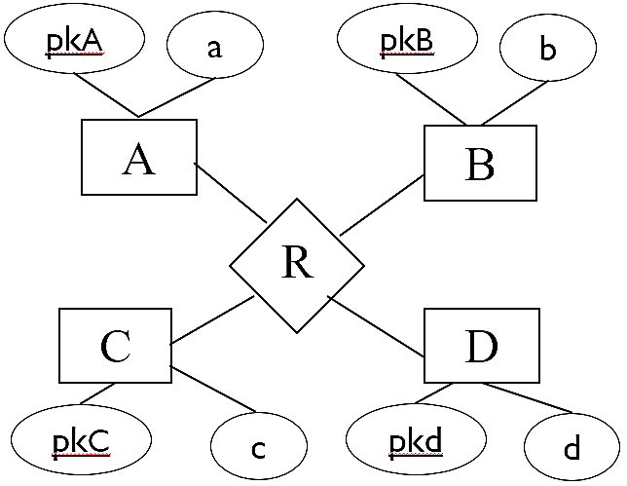
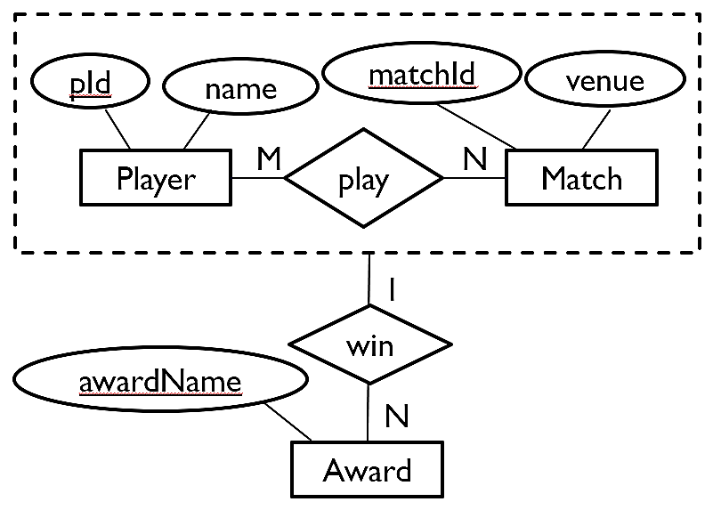
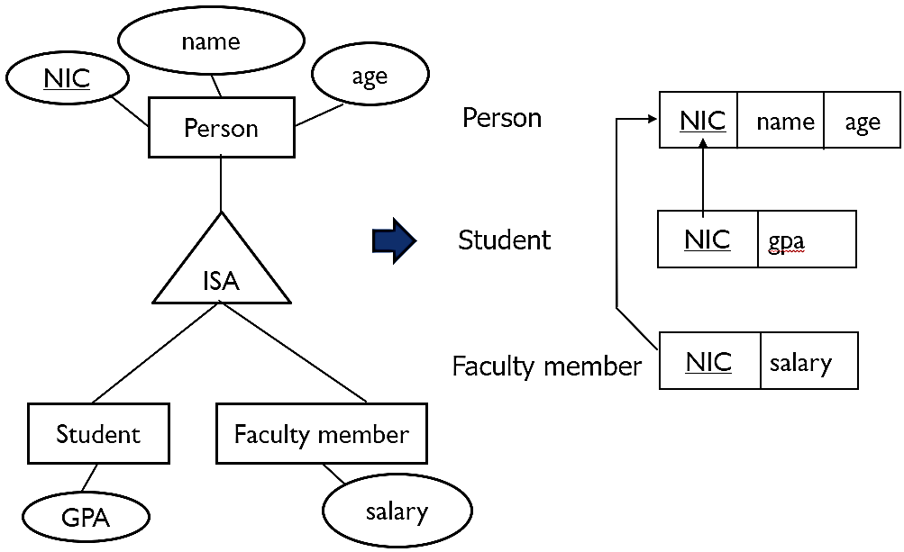
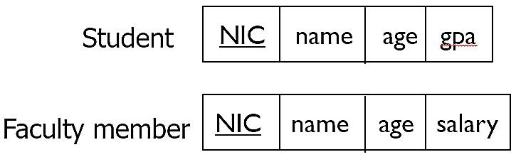
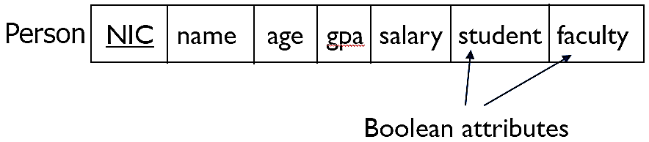
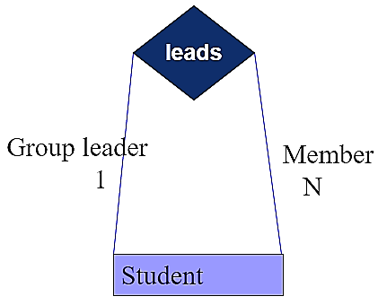
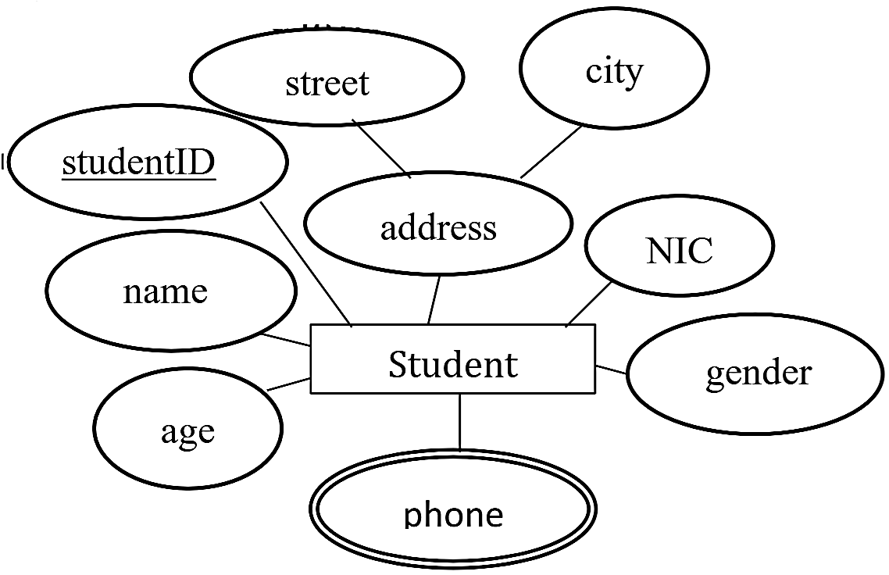
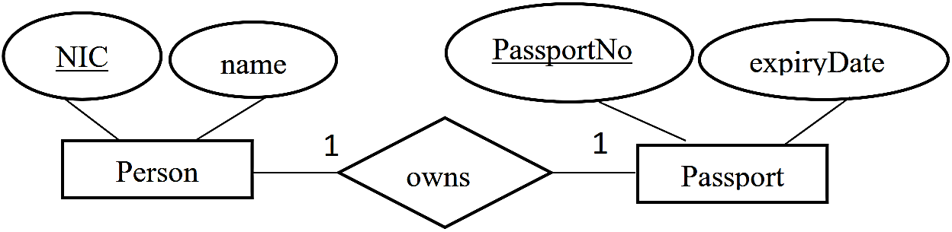
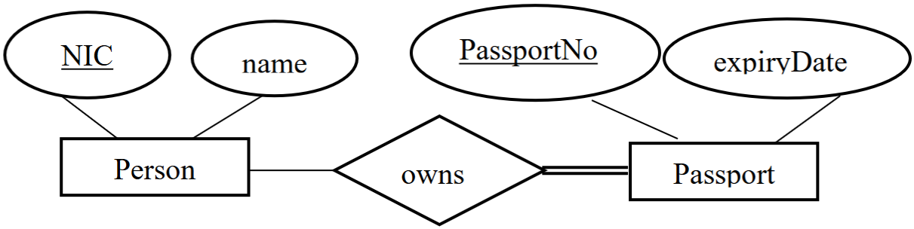
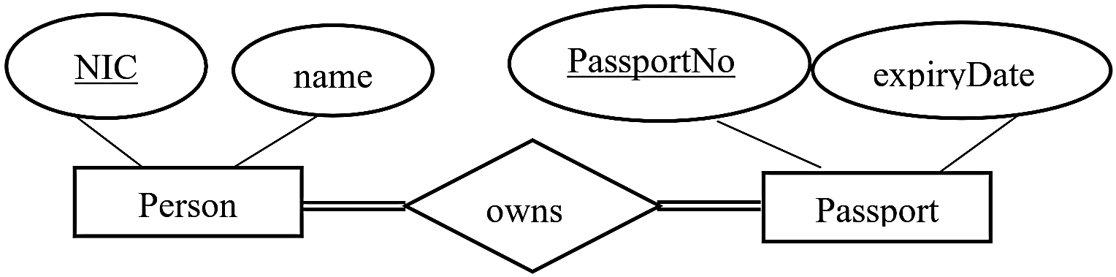
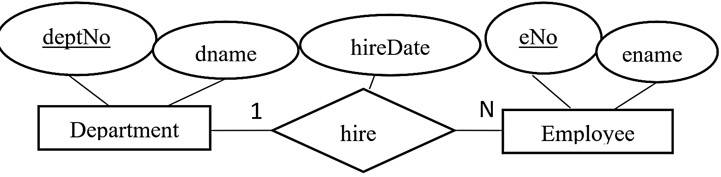
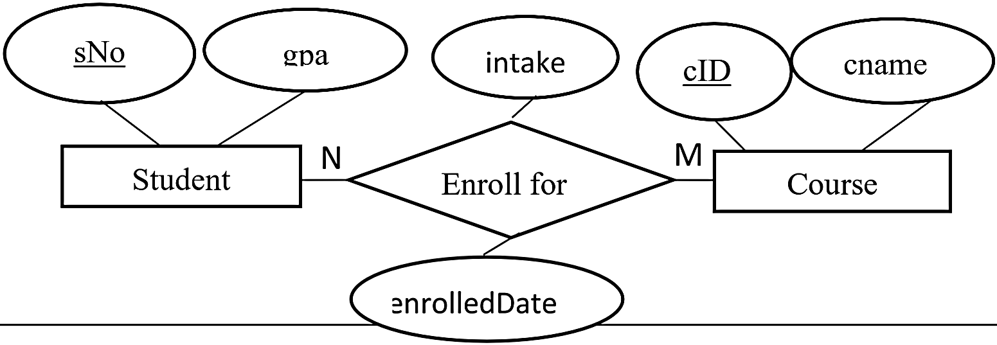
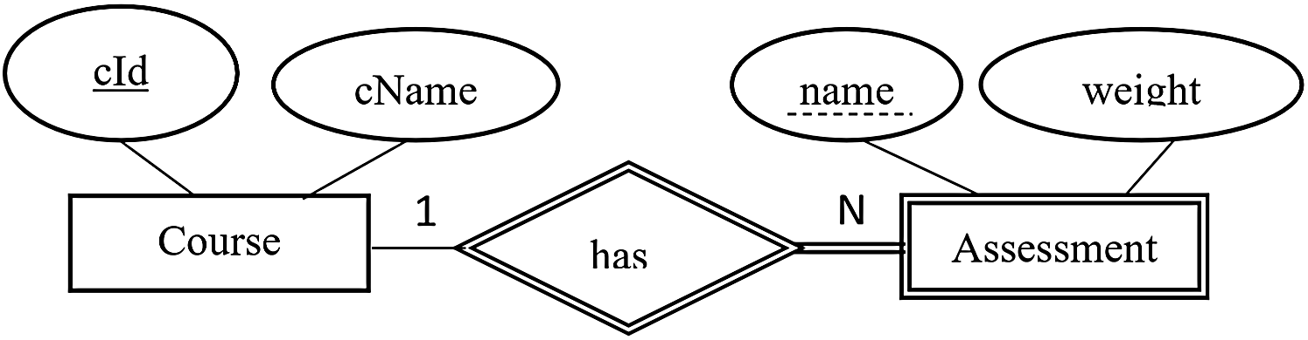
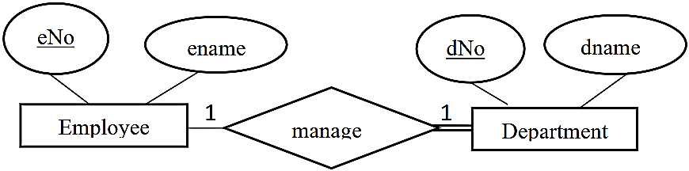
CREATE VIEW dept_info(dname, budget, manager)
AS
SELECT d.dname, d.budget, e.ename FROM emp e, dept d
WHERE e.eid = d.managerId

SELECT * FROM dept_info
SELECT dname FROM dep_info WHERE budget > 500,000

DROP VIEW dept_info

DECLARE @DName VARCHAR(20)

SET @DName = ‘SESD’

SELECT budget
FROM dept
WHERE dname = @DName

DECLARE @empId INT
SELECT @empId = MAX(eid)
FROM emp

IF (SELECT COUNT(eid) FROM emp) > 1000
BEGIN
PRINT ‘There are more than 1000 employees’
END
ELSE
PRINT ‘There are less than 1000 employees’

WHILE @count <= 100
BEGIN
INSERT INTO Employees VALUES(@count, CONCAT(‘Employee’, @count))
SET @count = @count + 1
END

CREATE FUNCTION getEmpCount(@did CHAR(12)) RETURNS int
AS
BEGIN
DECLARE @ecount int
SELECT @ecount = COUNT(*)
FROM works w
WHERE w.did = @did
RETURN @ecount
END

DECLARE @result int
EXEC @result = get_empCount ‘Admin’
PRINT @result

CREATE PROCEDURE addBooking(@showId int, @custName char(50), @numTickets int)
AS
BEGIN
INSERT INTO Booking VALUES(@showId, @custName, @numTickets)
UPDATE Show
SET spectators = spectators + @numTickets
END

EXEC addBooking 10, ‘Manirenkan’, 3

CREATE TRIGGER trigger_name
ON { table | view }
{ FOR | AFTER | INSTEAD OF } { [INSERT] [,] [UPDATE] [,] [DELETE] }
AS
BEGIN
Sql_statement[…n]
END

SELECT salary FROM emp
WHERE salary > (
SELECT salary FROM emp
WHERE ename = ‘Lakmal’
)

